Power Generation System from Human Footstep Using Microcontroller

Department of Computer Science and Engineering

Science, Engineering and Technology School

University of Khulna, Bangladesh

Declaration

We declare that this report is our original work and has not been submitted in any form for another degree or diploma at any university or other institute of tertiary education. Information derived from published and unpublished work of others has been acknowledged in the text and a list of reference is given.

Jannatul Ferdous

Roll Number: 130225

Department of Computer Science and Engineering

University of Khulna

Rafflesia Khan

Roll Number:

Department of Computer Science and Engineering

University of Khulna

Approval

Shaharima Islam

Roll Number: 130206

Department of Computer Science and Engineering

University of Khulna

The report titled “Power Generation System from Human footstep Using Microcontroller” has been submitted to the following respected Course Teachers of the department of Computer Science and Engineering in partial fulfilment of the requirements for the course of “” on 3rd May 2016 by Rafflesia Khan (ID: 130233), Jannatul Fedous (ID:130225),Shaharima Islam (ID:130206) and has been accepted as satisfactory.

Sarfaraz Newaz

Lecturer

Department of Computer Science and Engineering

University of Khulna, Bangladesh

Md Zahidul Islam

Assistant Professor

Department of Computer Science and Engineering

University of Khulna, Bangladesh

Dr. Md. Shamim Akhter

Assistant Professor & Head

Department of Computer Science

AIUB

Prof. Dr. Kamrul Hasan Talukder

Head of the Department

Department of Computer Science and Engineering

University of Khulna

Acknowledgements

It has been a privilege for us to study at the department of computer science and Engineering at University of Khulna, Bangladesh. I am highly indebt to our course supervisors Md Zahidul Islam, Assistant Professor and Sarfaraz Newaj, Lecturer for their untiring support, encouragement and able guidance at each and every step throughout this project. We admire their knowledge and feel ourselves as fortunate that we got such an opportunity, which will definitely go a long way in our personal career. We acknowledge the support from the whole of our Department and our head of department Prof. Dr. Kamrul Hasan Talukder for his invaluable maintenance support.

We would also like to thank our Vice Chancellor, Dean, Head as well as my respected teachers from Computer Science and Engineering Department.

We are thankful to our parents.

Above all, we pay our reverence to Almighty.

Abstract

With this alarming rate of demand, we need other alternative source of electricity. A number of research is ongoing to find out alternative power generation source. Some of them need other energy source, some other need expensive procedure. In this situation, if human activity can produce electricity that would be a significant contribution to the research of power generation from alternative sources. Especially in over populated area of the world and in public places for example, bus or train stations, market where every minute couple of hundred people walk by. This collective people’s footsteps can be used for power generation without causing any harm to people and environment. In this paper, the way of generating power from human footsteps using piezo electric technology has been described. If piezo sensor can be structured on floor and human walks on the floor, the electrical energy produced by the pressure of the footsteps is captured by floor sensors and converted to an electrical charge by piezo transducers, then stored and used as a power source. In this paper, the details of the complete procedure of power generation using piezo electric technology has been described.

DECLARATION 2

APPROVAL 2

ACKNOWLEDGEMENTS 4

ABSTRACT 5

INTRODUCTION 9

1.1 Problem Statement 10

1.2 Objective 11

1.3 Motivation 11

BACKGROUND 12

2.1 Sensor 13

2.2 Piezo Electric Sensor 13

2.3 Filtering 13

2.4 Unidirectional Current Controller 14

2.5 Rechargeable Battery 15

2.6 Voltage Divider 16

2.7 PIC16F877A Microcontroller 16

2.8 LCD Display 17

2.9 Analog to Digital Converter 18

2.10 Mobile Battery 18

2.11 Zener Diode 19

2.12 Bridge Rectifier 20

2.12 Capacitor 21

2.13 Switch 21

2.14 Principle of Power Generation using PIEZOELECTRICITY 22

2.12.1 Methodology 24

2.12.1.1 Sensor interface and Transducing: 24

2.12.1.2 Processing: 24

2.12.1.3 Storage: 24

HARDWARE IMPLEMENTATION 25

3.1 Circuit Diagram 25

3.2 Sensor interface Circuit 27

SOFTWARE IMPLEMENTATION 28

4.1 Code: 28

4.2 Flow Chart 28

PROPOSED METHODOLOGY AND WORKING PROCEDURE 30

5.1 Working procedure of the system 31

5.2 Features of proposed system 38

Chapter 6 39

Performance Evaluation 39

CHALLENGES SOLVED IN THE PROJECT 40

7.1 Connection among Sensor 40

7.2 Safely plot the sensors 40

7.3 Placing sensor on the carpet 41

7.4 Pressure exactly on the middle point 41

7.5 Getting positive /negative voltage 41

7.6 Microcontroller cannot receive voltage above 5V. 41

7.7 Determining the step on it 42

7.8 LCD display was not clear 42

CONCLUSION AND FUTURE WORK 43

8.1 Scope of the Project 43

8.2 Advantage, Limitation, Application 44

8.2.1. Advantage 44

8.2.2 Limitations 44

8.2.3 Applications 44

BIBLIOGRAPHY 45

Chapter 1

Introduction

Day by day, the population of the country increased and the requirement of the power is also increased. At the same time the wastage of energy also increased in many ways. But power generation conventional resources are now not enough for total demand of electrical energy. Therefore many researchers and engineers are working on non-conventional ways of electrical power generation. Reforming wasted energy back to usable form is the major solution. As technology is developed and the use of gadgets, electronic devices also increased. Power generation using conservative methods becoming deficient. There is a necessity arises for a different power generation method. At the same time the energy is wasted due to human locomotion and many ways.

We are enjoying the benefits of human-powered transport since time immemorial in the form of walking, running and swimming. However modern technology has led to machines to enhance the use of human-power in more efficient manner. There is a number of research on-going in this field. They are focused on developing system that utilize different form of human-power altogether and thereby the massive energy produced by mass population can be used in so many different formats. In this research context, pedal power is an excellent source of energy and has been in use since the nineteenth century making use of the most powerful muscles in the body. Ninety-five percent of the exertion put into pedal power is converted into energy [3]. Pedal power can be applied to a wide range of jobs and is a simple, cheap, and convenient source of energy. However, human kinetic energy can be useful in a number of ways but it can also be used to generate electricity based on different approaches and many organizations are already implementing human powered technologies to generate electricity to power small electronic appliances.

In relation to this human-empowered energy generation research field, foot step power generation system is a non-conventional electrical energy production system. It converts mechanical energy of foot step into electrical energy by using transducers. In this foot step power generation project is designed to convert foot step, walking and running energy into electrical energy. It is used to generate electricity from by walking or running on foot step. This power generation system can become very popular among populated countries like Pakistan, china, India. It can be implemented on roads, bus stations and many public places. Although this system is little bit expensive, but it can make a huge difference in electrical power generation of country. As we know generation of any form of energy is just to convert some other form of energy. Therefore, energy is existing, we are just not using it. Just a little initiative of covering the floor with proper piezo electric material can convert pressure generated by human footsteps and convert them to electricity. This could be just the initiative, later other human activities such as running over treadmill can be also used for power generation.

The remainder of this paper is structured as follows. Section II gives an overview of related work. Section III further elaborates on the principle of the proposed procedure. Section IV and V describe the proposed technology, its multi-layered architecture. Section VI evaluates proposed procedure and some challenges those has to be solved during our work. Finally, section VII concludes this paper with some remarks and discussion regarding future research on this topic.

# 1.1 Problem Statement

It is commonly accepted that the uses and demand for electricity will continue to grow and that new sources of electricity are important to the future of human technological progress. To answer the growing need for electricity, this thesis describes new work in the field of generating electricity from mechanical motion by presenting two novel micro-machined power generators.

# 1.2 Objective

# 

The objective of this thesis is to continue by motivated by the research work outlined above, proposing power generation systems which more efficiently harness electric energy from a piezoelectric source implanted on floor usually in places where massive population is available. The source characteristics and energy harvesting system upon the piezoelectric system presented. Specifically, the following points should be kept in mind while reading this report:

* Because a low-frequency piezoelectric source is essentially a capacitor and a parallel charge source, and Ec= ½CV2 describes the energy stored on a capacitor, it is advantageous to allow the source voltage to peak before removing the energy. The charge liberated per step cycle is relatively constant under the same loading force, regardless of walking speed. Therefore, an adapter has been used between the microcontroller and capacitor in order to pass controlled voltage.
* Output ripple is dominated by the low excitation frequency of walking. Therefore, output filter component selections must be based upon different criteria than usual. Further, a large output capacitance ( > 100 mF) must be included simply to keep the ripple voltage within acceptable limits.
* Because these systems are low-power and average source current is very low, semiconductor switches are selected to minimize gate charge, not ON resistance. Switching frequencies are chosen to minimize system energy loss, not filter component dimensions.

# 1.3 Motivation

Working of footstep power generation system consists of following main points:

* Piezoelectric sensor interfaced with microcontroller and used as a transducer to convert force energy into electrical energy
* It is consists of large number of Piezoelectric sensors connected in series. Kinetic energy of series connected transducers is converted into electrical energy.
* Voltages generated by piezoelectric sensors are feed to circuit elements to get proper output.
* Output energy is stored in batteries

Chapter 2

Background

The feasibility of harnessing waste energy from a variety of body “sources” has been explored in a previous studies at the MIT Media Laboratory hav. One conducted in 1995 analyzed a number of common human activities and concluded that the heel strike during walking is the most plentiful and readily-tapped source of this waste energy [3]. It has been estimated that 67 Watts of power is available in the heel movement of an average (68 kg) human walking at a brisk pace (2 steps per second with the foot moving 5 cm in the vertical direction) []. Admittedly, it would be impossible to unobtrusively scavenge all of that energy, but even a small percentage of it, removed imperceptibly, would provide enough power to operate many of the body-worn systems on the market today. The study further proposed a variety of methods to harvest this energy, including a piezoelectric (PVDF) film insert and a coupled resonant magnetic generator. A second Media Laboratory study amplified the assertion that shoe energy could easily be tapped and suggested a system of embedded piezoelectric materials and miniature control electronics [4]. It observed that a shoe or boot, because of the relatively large volume of space available in the sole and heel, would make an ideal test bed for the concept of body energy harvesting.

The only notable shortcoming among the three systems is the inefficiency of the power conditioning electronics used in the two piezoelectric RFID demonstration circuits. While sublime in its simplicity and low quiescent power requirement, the original Media Laboratory design is generally not well suited to the electrical characteristics of a piezoelectric source excited at the frequency of a brisk walk. In both cases, this circuitry consists of a four diode full-wave rectifier, a short-term storage capacitor that is valued (by necessity of the design) nearly three orders of magnitude greater than the capacitance of the source, a novel “latched-SCR” trigger for load switching, and a micro-power, commercial linear regulator.

The different main technology and tools those are used in this project are explained as following:

# 2.1 Sensor

A sensor is a device that measures a physical quantity and converts it into a signal which can be read by an observer or by an instrument. For example, mercury converts the measured temperature into expansion and contraction of a liquid which can be read on a calibrated glass tube. At thermocouple converts temperature to an output voltage which can be read by a voltmeter. For accuracy, most sensors are calibrated against known standards.

# 2.2 Piezo Electric Sensor

It is a sensor which converts force applied on sensor into voltage with the help of mechanical vibrations. It basically converts kinetic energy into electrical energy. Array of sensors should be connected in series to generate reasonable amount of electrical power. For example 10 piezoelectric sensors are connected in series; they will generate 9 volt and 100mA current. Two types of such sensors are available in market lead zirconite titanate (PZT) and PVDF. The output voltages of these sensors are controlled by filters.

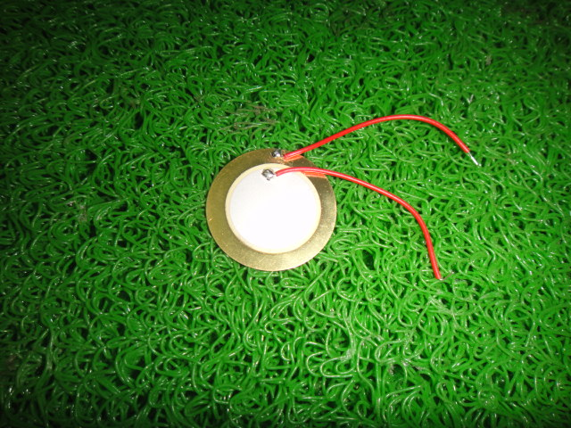

Fig-2.1: Piezoelectric sensor used in our project.

# 2.3 Filtering

#### 

Capacitor is used as filter to remove AC components from sensors output voltages.  A capacitor stores minute’s voltages with charging and discharging phenomenon. Capacitor acts like a short circuit for AC voltages and open circuit for DC voltages. Output of filter is fed to unidirectional current controller. Voltage Sampler or sample and hold circuit is an essential analog building block and the applications of voltage sampler includes switched capacitor filters and analog-to-digital converters. The main function of the sample and hold circuit is to sample an analog i/p signal and hold this value over a particular length of time for subsequent processing. Sample and hold circuit is designed using only one capacitor and one MOS transistor. The working of this circuit is straight forward. When CK is high, then the MOS switch will be ON, which in turn permits output voltage to track input voltage. When CK low, then the MOS switch will be OFF.

[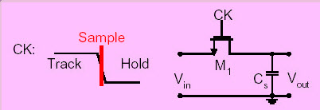](https://www.elprocus.com/wp-content/uploads/2015/07/Voltage-Sampler.jpg)

Fig-2.2: Voltage simpler

# 2.4 Unidirectional Current Controller

Diodes and triacs are used as unidirectional current controllers. Diode and triac based charge controller can be used to charge lead acid battery. In this project, triac based battery charger is used**.** [Triac firing angle control circuit](http://microcontrollerslab.com/firing-angle-control-circuit-triac/" \t "_blank) is used to control flow of charge into battery. It will make the flow of current in one direction only by conducting in one direction only.  It is used to protect back current to array of sensors.  After that voltage is fed to lead acid battery and voltage divider which is connected with PIC16F877A microcontroller.

[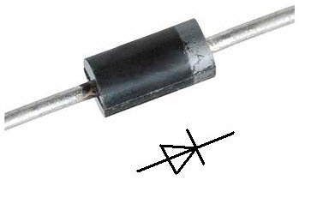](https://www.elprocus.com/wp-content/uploads/2015/07/1N4007.jpg)

Fig-2.3: Diode

# 2.5 Rechargeable Battery

[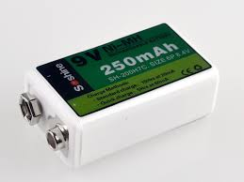](https://www.elprocus.com/wp-content/uploads/2015/07/Lead-Acid-Battery.jpg)A rechargeable battery is an energy storage device that can be charged again after being discharged by applying [DC](http://whatis.techtarget.com/definition/DC-direct-current) current to its terminals. Rechargeable [batteries](http://searchmobilecomputing.techtarget.com/definition/battery) allow for multiple usages from a cell, reducing waste and generally providing a better long-term investment in terms of dollars spent for usable device time. This is true even factoring in the higher purchase price of rechargeable and the requirement for a charger. A rechargeable battery is generally a more sensible and sustainable replacement to one-time use batteries, which generate current through a chemical reaction in which a reactive anode is consumed. The anode in a rechargeable battery gets consumed as well but at a slower rate, allowing for many charges and discharges.

Fig-2.4: Rechargeable battery.

# 2.6 Voltage Divider

Voltage divider lowers the voltage to the level of microcontroller. We can’t fed 12 volt directly to microcontroller. Voltage divider is used to divide the voltage. After that pic microcontroller reads the analog voltage and displays on the LCD.

# 2.7 PIC16F877A Microcontroller

PIC16F877A microcontroller is main part of foot step power generation system. It is used to display battery voltage on LCD. It is also used to measure battery voltage with the help of analog to digital converter of pic microcontroller. 10MHz crystal is used in this project. Some of its pins functions are,

* ADC0,ADC1 are used to display the voltage
* 16MHz crystal is used to generate oscillating frequency
* RS pin is used to select the register
* Enable pin is used to enable the write operation
* RC0-RC7 pins are used as parallel ports
* Pin VEE is used to adjust the contrast of display

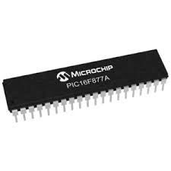

Fig-2.5: PIC16F877A microcontroller.

Different Pin of the microcontroller has been used for our project. Fig [2.6] shows different pins of the microcontroller.

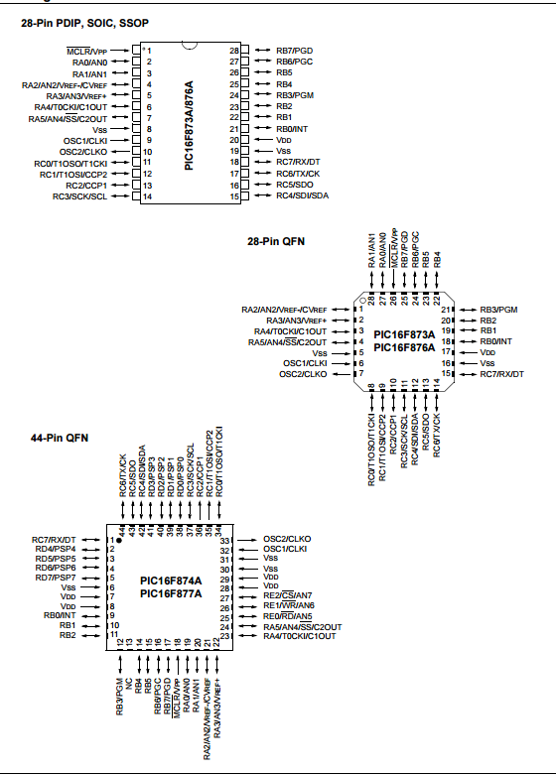 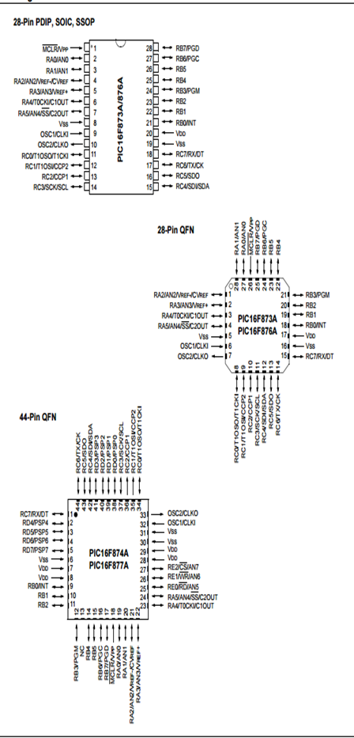

Fig- 2.6: Different PIN for Microcontroller

# 2.8 LCD Display

16X2 LCD is interfaced with microcontroller.[LCD interfacing with pic microcontroller](http://microcontrollerslab.com/lcd-interfacing-pic16f877a-microcontroller/) is very simple task.  It is used to display status of sensors and battery voltages. A image of LCD in shown below:

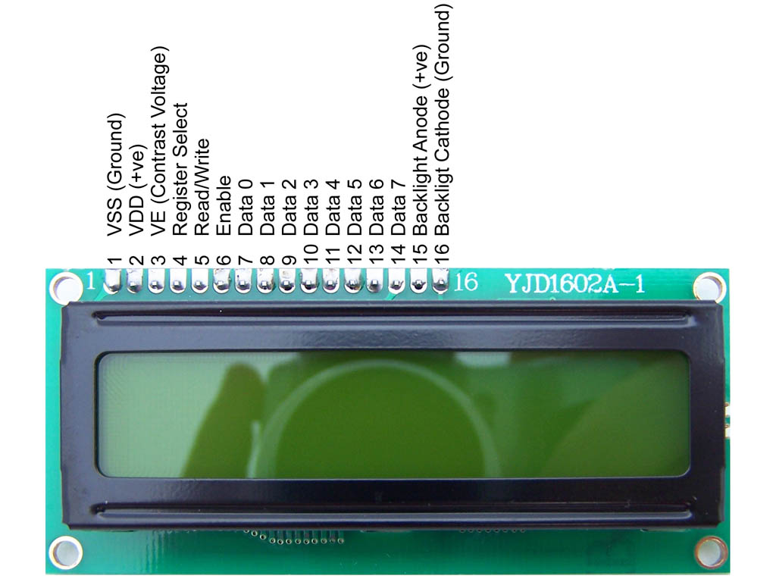

Fig-2.7: LCD Display.

# 2.9 Analog to Digital Converter

An ADC (analog-to-digital converter) is a device that converts analog to digital symbols. An a[nalog to digital converter](http://www.elprocus.com/analog-digital-converters/" \t "_blank) may also offer an isolated measurement. The reverse operation is achieved by a DAC (digital-to-analog converter). Typically, this is an electronic device that alters an analog input like voltage or current to a digital output, which is related to the magnitude of the voltage or current. Nevertheless, some partially electronic devices like rotary encoders, can also be considered as ADCs.

# 2.10 Mobile Battery

A mobile battery is a **lithium-ion battery**  and a **lithium-ion battery** (sometimes **Li-ion battery** or **LIB**) is a member of a family of [rechargeable battery](https://en.wikipedia.org/wiki/Rechargeable_battery) types in which [lithium](https://en.wikipedia.org/wiki/Lithium) ions move from the negative [electrode](https://en.wikipedia.org/wiki/Electrode) to the positive electrode during discharge and back when charging. Li-ion batteries use an intercalated lithium [compound](https://en.wikipedia.org/wiki/Chemical_compound) as one electrode material, compared to the [metallic](https://en.wikipedia.org/wiki/Metal) lithium used in a [non-rechargeable](https://en.wikipedia.org/wiki/Primary_battery) [lithium battery](https://en.wikipedia.org/wiki/Lithium_battery). The [electrolyte](https://en.wikipedia.org/wiki/Electrolyte), which allows for [ionic movement](https://en.wikipedia.org/wiki/Ionic_movement), and the two electrodes are the constituent components of a lithium-ion [battery cell](https://en.wikipedia.org/wiki/Battery_cell).

Here in our project we have used a Symphony mobile battery. Which we have used as a electrical device

That get charged by our power generation system.



Fig-2.9: Mobile Battery.

# 2.11 Zener Diode

# A Zener Diode is a special kind of diode which permits current to flow in the forward direction as normal, but will also allow it to flow in the reverse direction when the voltage is above a certain value - the breakdown voltage known as the Zener voltage.

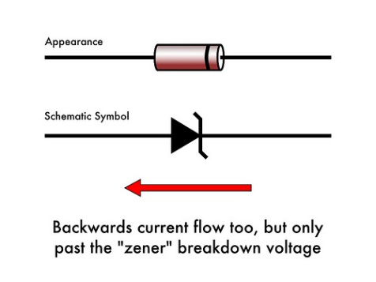

Fig-2.10: Zener Diode.

Zener diodes are widely used to regulate the voltage across a circuit. When connected in parallel with a variable voltage source so that it is reverse biased, a Zener diode conducts when the voltage reaches the diode's reverse breakdown voltage. From that point it keeps the voltage at that value.

In the circuit shown, resistor R provides the voltage drop between UIN and UOUT. The value of *R* must satisfy two conditions:

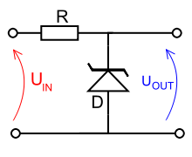

Fig-2.11: Zener Diode working circuit.

1. *R* must be small enough that the current through D keeps D in reverse breakdown. The value of this current is given in the data sheet for D. For example, the common BZX79C5V6[[1]](https://en.wikibooks.org/wiki/Electronics_Handbook/Components/Diodes/Zener" \l "cite_note-1) device, a 5.6 V 0.5 W Zener diode, has a recommended reverse current of 5 mA. If insufficient current exists through D, then UOUT will be unregulated, and less than the nominal breakdown voltage (this differs to voltage regulator tubes where the output voltage will be higher than nominal and could rise as high as UIN). When calculating *R*, allowance must be made for any current through the external load, not shown in this diagram, connected across UOUT.
2. *R* must be large enough that the current through D does not destroy the device. If the current through D is *I*D, its breakdown voltage *V*B and its maximum power dissipation *P*MAX, then I_D V_B < P_{MAX}.

# 2.12 Bridge Rectifier

A bridge rectifier is an arrangement of four or more diodes in a bridge circuit configuration which provides the same output polarity for either input polarity. It is used for converting an alternating current (AC) input into a direct current (DC) output. A bridge rectifier provides full-wave rectification from a two-wire AC input, therefore resulting in lower weight and cost when compared to a rectifier with a 3-wire input from a transformer with a center-tapped secondary winding.

Here we have used this to stable the sensor voltage or to convert it from AC to AC.

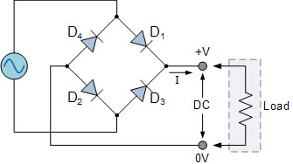

Fig-2.12: Bridge Rectifier .

# 2.12 Capacitor

A device used to store electric charge. Capacitors consist of two chargedmetal plates separated by an electrical insulator. The charge is suppliedby connecting the plates to a source of electricity. The positive charge isstored on one of the plates, and the negative charge is stored on theother. Capacitors are used to regulate the flow of charge in electriccircuits. The ability of a capacitor to store charge is called its capacitance. The capacitance depends on the size of theplates, the type of insulator, and the amount of space between the plates.

A capacitor is charged when electronsfrom a power source, such as a battery, flow to one of the two plates. Because theelectrons cannot pass through theinsulating layer, they build up on the firstplate, giving it a negative charge.Electrons on the other plate are attractedto the positive terminal of the battery,causing that plate to become positively charged.

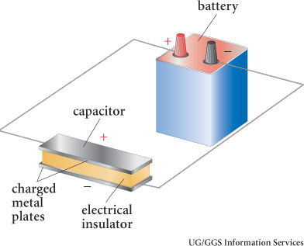

Fig-2.13: Capacitor Function.

# 2.13 Switch

A switch responds to an external force to mechanically change an electric signal. Switches are used to turn electric circuits ON and OFF and to switch electric circuits.

We have used the Switch to hold the capacitor voltage , so that it does not get discharged.

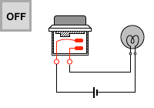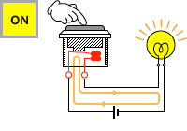

Fig-2.14: Switch Function.

# 2.14 Principle of Power Generation using PIEZOELECTRICITY

Foot step power generation system basically converts force energy of foot into electrical energy by using piezoelectric sensor. Piezoelectric sensor is transducer which converts force energy into electrical energy. This new way is based on the principle “PIEZOELECTRICITY”. It means that whenever any mechanical stress or pressure is applied on certain crystals, an electrical potential is developed over the crystal lattice. Fig [2.8] describes the working procedure of the proposed system.

When this electrical potential is not shorted an electrical voltage is created. This proposed System generate voltage on each and every step of a foot on an array of sensor. For this purpose, piezoelectric sensor is used in order to measure force, pressure and acceleration by its change into electric signals. This system uses voltmeter for measuring output, led lights, weight measurement system and a battery for better demonstration of the system. Usually, voltages which is produced from piezoelectric sensor is A.C voltages that need to be converted to D.C for our project, so for this purpose rectifier circuit is used. Either half wave rectifier or full wave rectifier can be used for this purpose. However, full wave rectifier because it gives full value. So A.C voltages are converted in to D.C voltages with this rectifier. Using battery charger circuit it is possible to charge the battery and this D.C voltages is stored in the lead acid battery of 12 volt.

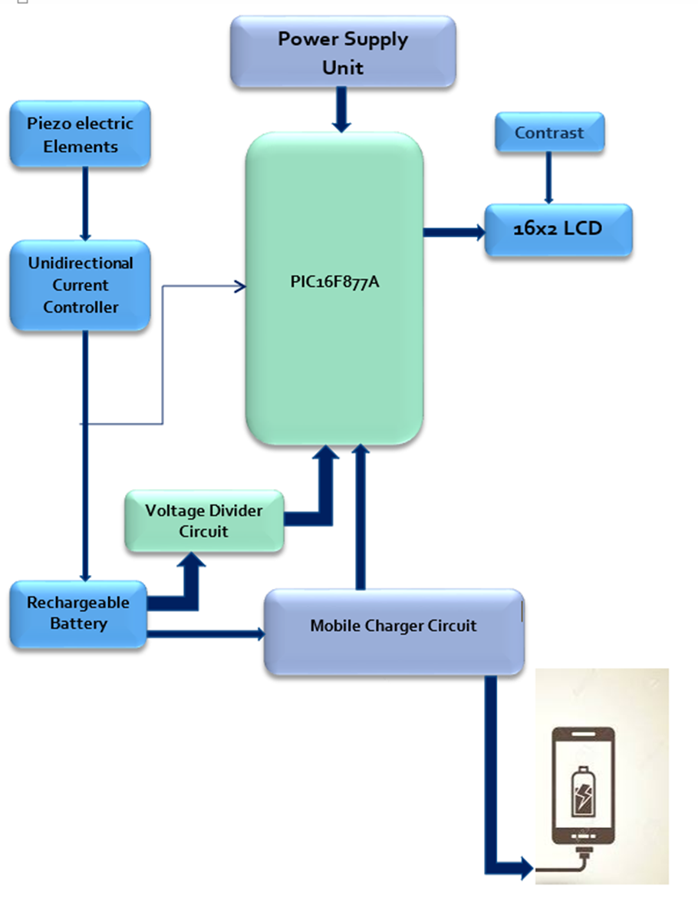

Figure 2.9: Block Diagram of Piozoelectronic energy harvesting circuit using Human footstep

Lead acid battery of 12 volt which is charged is now further connected to the inverter. As we have D.C voltages stored in the battery but we need A.C voltages because mostly load need A.C voltages so by using the inverter circuit which is such designed that it inverts the voltages from battery which is 12 volt D.C to 220 volt A.C voltages.

So this A.C voltage is used in different appliances such as for charging the laptop battery and also to charge the handset, it can also be used to lightening up the energy savor. If we need more power from this technique then used more steps for more electric current, and also increase the connection of piezoelectric sensor which is connected parallel and series combination and by vibrating with the help of footsteps gives electrical power which is in the form of electric current. Then ability of battery and inverter should be increased, battery should be of high current and voltages and inverter is such designed that it convert that electrical power to A.C voltages and also no loss in it, then output power will be increased and can be used more electrical appliances and also can be used such appliances which need more electric current.

## **2.12.1 Methodology**

The working of footstep power generation system involves three distinct phases.

### **2.12.1.1 Sensor interface and Transducing:**

* Consists array of piezoelectric sensors.
* Kinetic energy is converted into electrical energy

### **2.12.1.2 Processing:**

Here the generated degraded vibrating voltage will be fed to different blocks of circuit element to get a proper output.

### **2.12.1.3 Storage:**

Resultant output will be stored in a battery

Chapter 3

Hardware Implementation

# 3.1 Circuit Diagram

A Circuit diagram is shown below. It’s the Circuit diagram of our project by carefully following this circuit diagram we can make the power generation system so easily .Here all the components that are needed for this project is connected so as all these can perform their jobs perfectly and make the foot step power generation system. Here a volt Metter is added with the circuit as the destination component where we will send the produced electricity. This volt Metter will show the produced amount of electricity in digital form. The Switch there completes the circuit. When it is ON the circuit completes and electricity goes to the volt Metter.

Here is Fig-3.1 the circuit diagram is the diagram that we have drown using Proteus 8.1 Software for simulation. We have also run simulation on this circuit diagram, and it is running properly. Proteus 8.1: We use Proteus software to create electronic circuit schematic and then simulate our project before implement our project into real application. Proteus software offers many tools and microcontroller program support. So many user can simulate their project plan before implement to real condition.

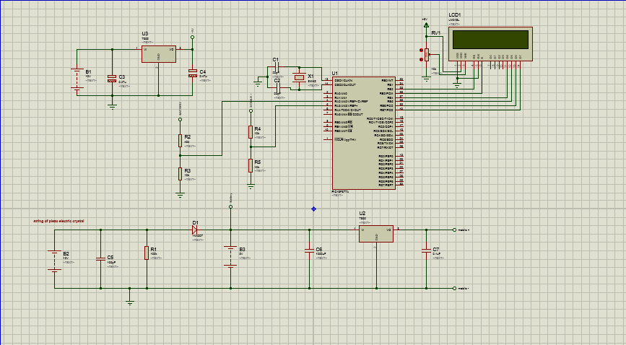Fig- 3.1: Circuit Diagram of Power Generation System using Microcontroller from Human Foot Step.

# 3.2 Sensor interface Circuit

Fig. [3.2] Describes the circuit of piezo sensor interface circuit

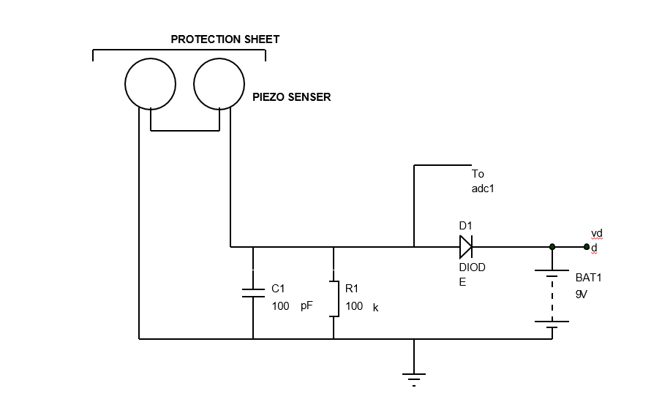

Fig-3.2: Sensor Interface Circuit

Chapter 4

Software Implementation

# 4.1 Code:

Coding is the main part of this project. A full complete code or program would give life to all components that are used in this project. Here we r going to use Assembly Language as the programming language. Mainly the microcontroller PIC16F877A would be programmed for various purpose like,

• Firstly it would instructed to receive the voltage send by the piezoelectric sensor.

• Initialize the LED and ADC and show a welcome massage.

• Is there is battery is receiving voltage from piezoelectric sensor LED would display battery charging.

• When the Switch is on and there is charge on battery the component (destination device) would receive charge or electricity otherwise not.

• Also we would try to program the microcontroller such that it can make the LED to show the number of foots that is stepped on the Sensor at a certain duration of time.

# 4.2 Flow Chart

The flow chart of the software has been described in Fig [4.1]. The software has been implemented in order to control the LCD display based on the generated voltage and the voltage that is being charging at any given point of time,

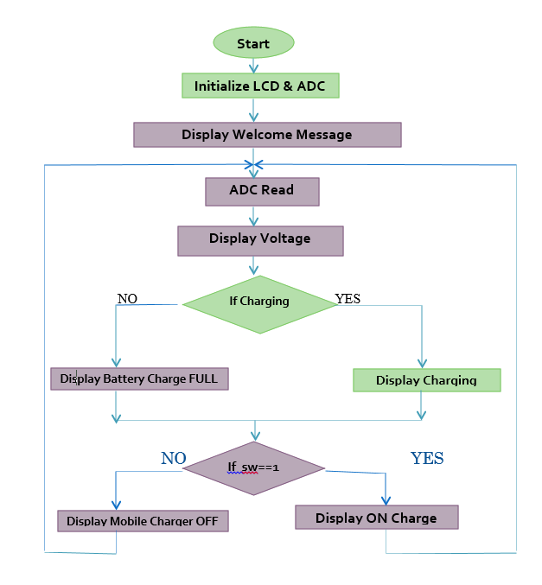

Fig- 4.1: Flow Chart for the software implementation

Chapter 5

Proposed Methodology and Working procedure

The working procedure for the proposed methodology can be depicted in Fig. [5.1]. There are several feature that need to be described in this section.

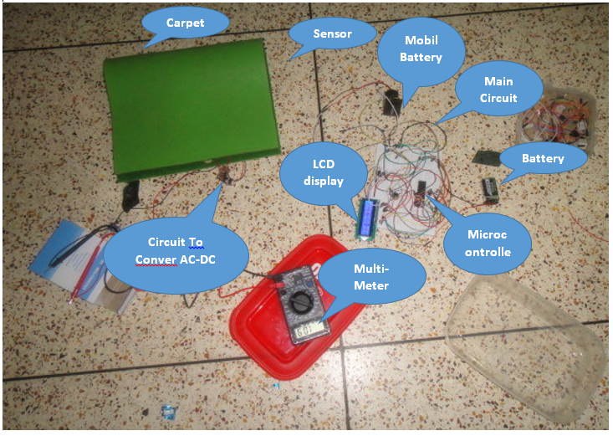

Fig- 5.1: Full System

From the picture, it can be seen that the main component for the proposed system are as following

* Microcontroller
* Main Circuit
* LCD display
* Mobile Battery
* Rechargeable Battery
* Sensor
* Carpet
* Circuit to convert AC voltage to DC Voltage
* Multi-meter

# 5.1 Working procedure of the system

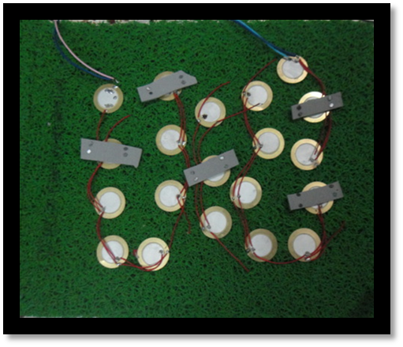In this project we have used series connection between the piezo sensors. The benefits of using parallel connection over series connection is, current obtained from series connection is less than that from parallel connection. Therefore, for optimum voltage and current a parallel connection is perfect where a good voltage as well as current can be obtained. Next step is, another circuit has been used to convert the AC voltage to DC voltage. Fig. [5.2] shows the parallel connection that has been used in this proposed system. However for better understanding and clarification.

Fig- 5.2: Parallel Connection

The next step is to connect the sensors connection with the capacitor. Therefore all the voltage generated in the sensors can be stored in a regulated manner. Fig-5.3 describes the circuit for the sample and hold procedure for our project. Sample-and-hold (S/H) is an important analog building block with many applications, including analog-to-digital converters (ADCs) and switched-capacitor filters. The function of the S/H circuit is to sample an analog input signal and hold this value over a certain length of time for subsequent processing.

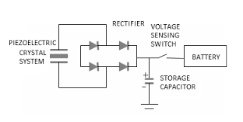

Fig-5.3: Sample- Hold Circuit

Taking advantages of the excellent properties of MOS capacitors and switches, traditional switched capacitor techniques can be used to realize different S/H circuits [1]. The simplest S/H circuit in MOS technology is shown in Figure 1, where Vin is the input signal, M1 is an MOS transistor operating as the sampling switch, Ch is the hold capacitor, ck is the clock signal, and Vout is the resulting sample-and-hold output signal.

In the simplest sense, a S/H circuit can be achieved using only one MOS transistor and one capacitor. The operation of this circuit is very straightforward. Whenever ck is high, the MOS switch is on, which in turn allows Vout to track Vin. On the other hand, when ck is low, the MOS switch is off.

During this time, Ch will keep Vout equal to the value of Vin at the instance when ck goes low. CMOS Sample-and-Hold Circuits Page .Unfortunately, in reality, the performance of this S/H circuit is not as ideal as described above. The next section of this paper explains two major types of errors, charge injection and clock feed through, that are associated with this S/H implementation. The section after that presents three new S/H techniques, all of which try to minimize the errors caused by charge injection and/or clock feed through..

As we know the pressure is directly proportional to amount of power generated

P α Wt

Here we take the constant of proportionality as Қ, then the equation becomes

P = Қ Wt

Where,

Қ- Constant of proportionality

Wt-weight

P-power

We know that for wt=50kg, we get the value of voltage V=4v and I =0.015A

Then P=V\*I=4\*0.015=0.06w, means we can say that for 50kg we get power

(P) =0.06w

From this we can find the value of Қ

Қ=P/wt=0.06/50=0.001

Fig [3.4] shows the circuit for capacitor and switch in order to store generated electricity in a capacitor. This small circuit consists of bridge rectifiers, a voltage sensing switch and capacitor which can store 1000μF electricity and 25V voltage. The sensors connection in Fig [3.2] is connected to the circuit shows in Fig [5.4].

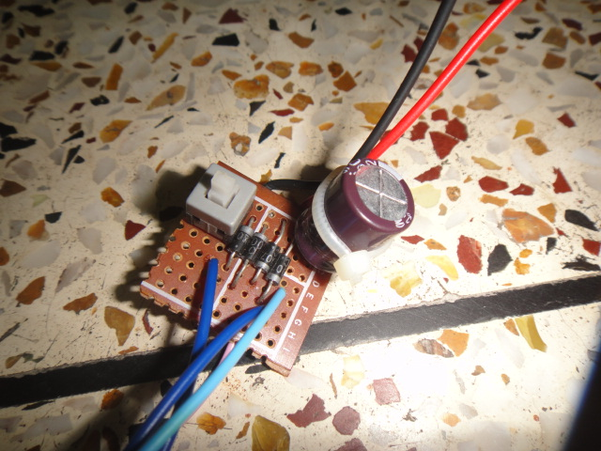

**Capacitor**

**Switch**

**Bridge Rectifier**

Fig-5.4: Small Sample- Hold Circuit in our project

Once human footstep causes pressure on the sensors shows in Fig [3.2] and sufficient amount of electricity are generated, if the switch shows in Fig [3.4] is on, the electricity are stored in the capacitor. Before storing the voltage, bridge rectifier transforms generated AC supply into DC power. This capacitor is connected to battery for storing all generated voltage.

Fig [5.5] shows the main microcontroller circuit of our project. Its has a LCD a variable register has been used in order to clear the reading of the LCD and there is also a variable regulator has been used in order to control the voltage passing between capacitor and battery as well as the mobile charger that uses the generated energy.

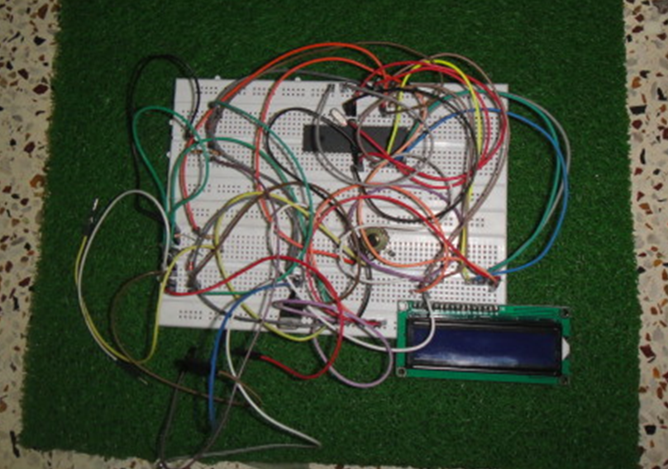

Fig-5.5: Main Microcontroller Circuit in our project

Here microcontroller is connected LCD is connected with it. LCD shows the status. At the initialization the LCD is exactly same as Fig [5.6].

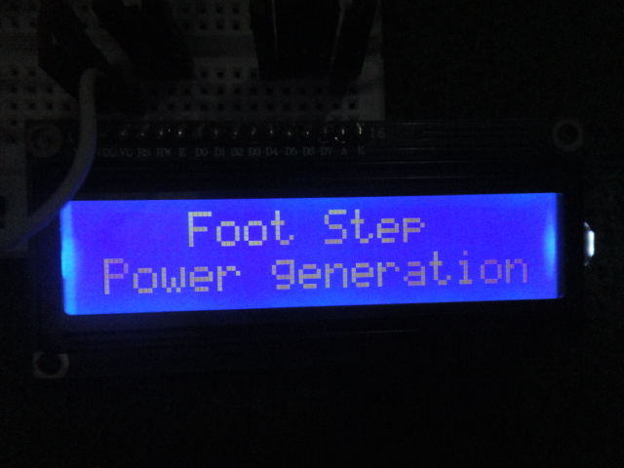

Fig-5.6: Initialization stage of the system

The next stage has been depicted in Fig [5.7] which is showing the rechargeable and mobile battery, showing the status of Rechargeable battery (Voltage going )and Mobil battery(Voltage receiving).

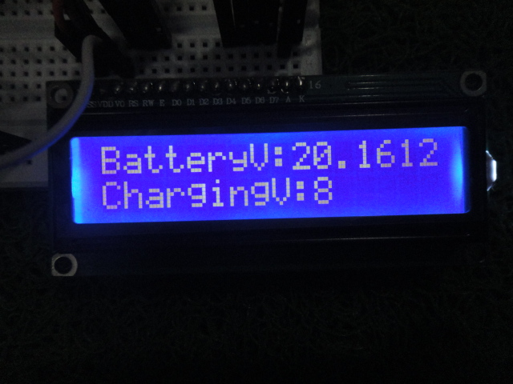

Fig-5.7: Status of Rechargeable battery (Voltage going )and Mobil battery

Fig [5.8], showing the number of step that is stepped on the carper for getting the voltage that is stored in the Rechargeable battery. Here is one thing important that it is hard to know is all sensors have got pressure from a particular step or not. Did every sensors received pressure from every step? Which is hard to know. By running so many test cases we have determined that our used one sensor gives .1 voltage when it is just pressured one time. Here we are showing Fig [5.8] the step number that is approximately received by all of the sensors not that one that is received by the system.

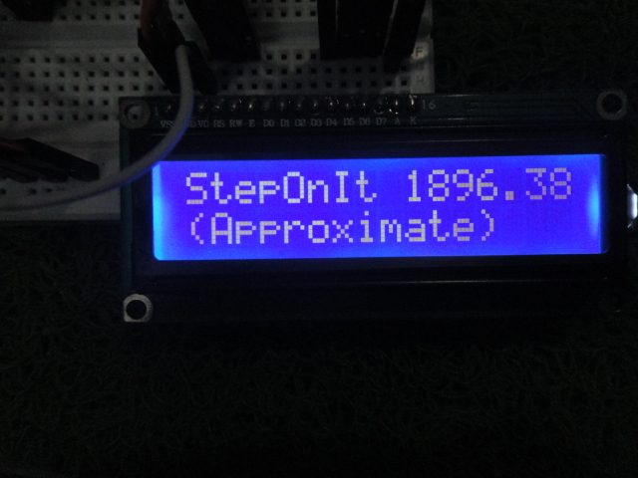

Fig-5.8: The number of foot-step

One the system is initialized and people walk over the carpet, there are pressure on the sensors, electricity is generated. Fig [5.9] shows the pressure of footsteps on the sensors is harvesting electricity.

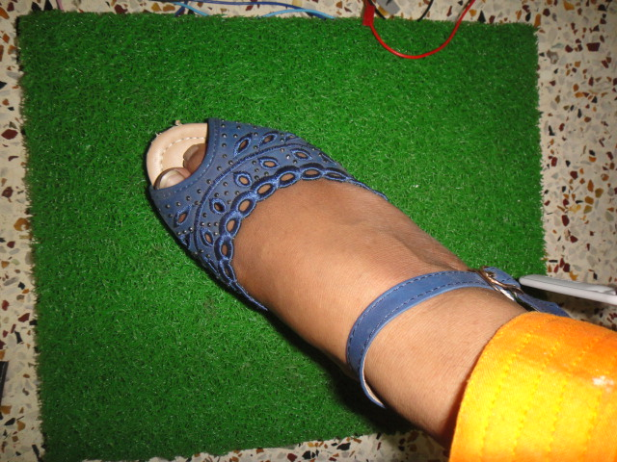

Fig-3.9: While stepping on the voltage is generating

Once the electricity starting generated and the capacitor is storing the voltage, the voltage charge the rechargeable battery which is connected to the capacitor, shows in Fig [5.10] and thereby the stored voltage in the capacitor is passed to the rechargeable battery.

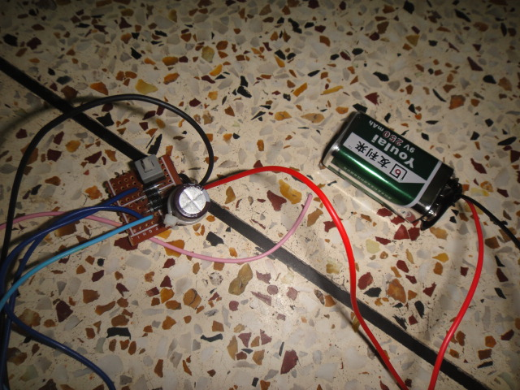

Fig-3.10: Rechargeable battery connected to the Small Circuit along with sensor.

The generated voltage can be measured using multi-meter. In Fig [5.11] the multi-meter shows the reading of generated voltage.

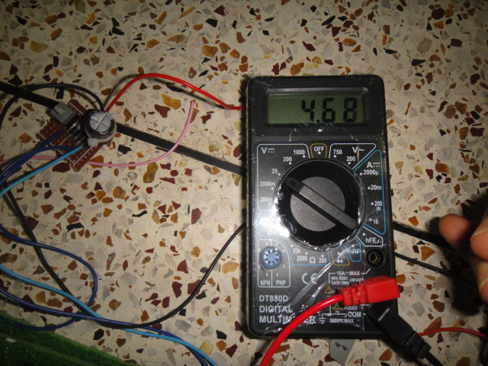

Fig- 3.11: Meter is giving the rating of generated voltage

In order to use the voltage stored in the rechargeable battery, in Fig [5.8], we have used mobile battery to charge which is connected to the main microcontroller circuit shows in Fig [5.5]. In Fig [5.12], the connection between main microcontroller circuit and the mobile battery has been depicted.

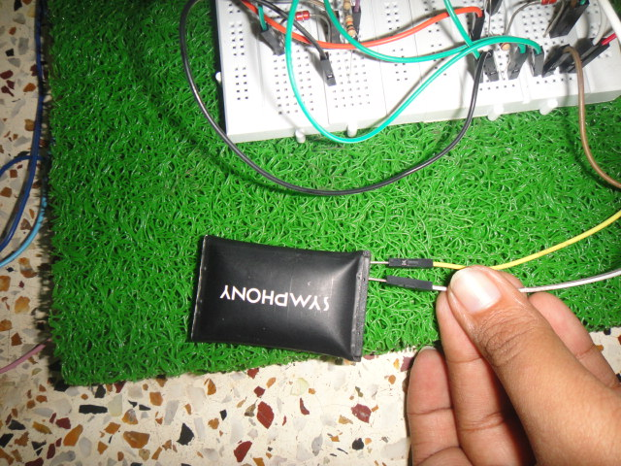

Fig-5.12: Mobile battery connected to the Main Circuit

# 5.2 Features of proposed system

1. Easy interface to all microprocessors
2. Operates ratio metrically or with 5 VDC or analog span
3. Adjusted voltage reference
4. No zero or full-scale adjust required
5. 8-channel multiplexer with address logic
6. 0V to VCC input range
7. Outputs meet TTL voltage level specifications

Chapter 6

Performance Evaluation

As we have approximated that the distance at which if we have installed our system is 250 ft and stride is 5   then

Total energy = 5.096

Total energy = 254.8 J

Now convert this energy to total units produced by a single person i.e.

Units produced = 254.8 J

Units produced = 0.0000707 KWh

This is the units produced by a single person i.e.

Units produced by a person = 0.0000707

Let the total numbers of people include students, faculty, lab staff and works are 2500 and they passes through that area 4 times in a day so

Units produced in a day = 0.0000707 x 10,000

Units produced in a day = 0.707 kWh

So this is the calculation of our project per day. This states that if we install in a gallery of our campus which has 250ft length and if total numbers of persons visit it more than one in a day then the numbers of units produced will be 0.707 kWh in a day.

 We can increase it by increasing the number of tiles i.e. increasing area to 400 or 500 ft and at that spot at which maximum number of people visits more than once in a day.

|  |  |
| --- | --- |
| Units produced in a day on the assumption we take | 0.707 kWh |
| Units produced in a week on the assumption that working days are 5 | 3.535 kWh |
| Units produced in a semester on the assumption that there are 17 weeks in a semester | 60.095 kWh |

**Table 6.1 Footstep power generation calculations**

These are the calculation on the bases of 250ft length of area in which we install the system and 2500 people visits it approximately 4 times in a day.

Chapter 7

Challenges Solved in the Project

While implementing the proposed system, we came to the following challenges

# 7.1 Connection among Sensor

The benefits of using series connection over parallel connection is, although amount generated voltage from a series connection is more than that from parallel connection. However the current obtained from series connection is less than that from parallel connection.

*Solution:* In this project, for optimum voltage and current a parallel connection is perfect where a good voltage as well as current can be obtained.

# 7.2 Safely plot the sensors

All the sensors must be placed over the floor in a specific manner. Therefore, they can be long-lasting and the maximum pressure generated by human footsteps can be applied on the sensors. The connection among them must be very strong enough so that continuous footstep cannot disconnect them.

*Solution*: In this project, we have used Shoe sole and very small pin to place it on the carpet on a perfect position strictly. The pins is not harmful for any step. We did no use gum because gum damages the function of the sensor. This was also not effective. For specifically giving sufficient pressure on the sensors we have placed a small piece of shoe shell in the center of each sensor so that when footsteps are placed on the sensor it make enough pressure in the center.

# 7.3 Placing sensor on the carpet

All the sensors are placed over carpet on the floor and they are also covered with another carpet. This carpet covering must be still and there can not be any loose attachment among them otherwise it will destroy the connection and the circuit of sensors.

*Solution*: Joint the 2 using very small pin not harmful which we have tested as well.

# 7.4 Pressure exactly on the middle point

If the pressure can be put at exactly on the center of the sensor, it gives better result.

*Solution*: We have put a fat small part of shoe sole on the middle of every sensor. This problem can also be solved by using a crystal format for the sensors.

# 7.5 Getting positive /negative voltage

For capacitor, we need DC voltage, however the sensor is giving the AC flow.

*Solution*: We have used Bridge rectifier in order to transform AC flow to DC voltage.

# 7.6 Microcontroller cannot receive voltage above 5V.

For every band of microcontroller there is a fixed amount of voltage that it can take. Therefore, it need regulated voltage to be passed.

*Solution*: We have used voltage regulator 7805 (05 means it only sends 5V to a device).

# 7.7 Determining the step on it

How many footsteps required to generate some amount of electricity? Answering this question was bit challenging. We required an automated and generalize formula that can answer this question.

*Solution*: We have generated lots of test case and finally come to the point that our used one sensor gives .1 voltage when it is just pressured one time. Here we are showing the step number that is approximately received by all of the sensors not that one that is received by the system.

# 7.8 LCD display was not clear

The LCD display was not clear all the time.

*Solution*: used a register with the microcontroller that maintains the voltage passing to it also used a variable resistor

Chapter 8

Conclusion and Future Work

This project is cost effective, flexible and safe for putting in public. Therefore, piezoelectric energy harvesting is definitely promising source of alternative energy. Future work for piezoelectric energy harvesting using human footsteps can be extended by including advanced material, chemical crystal used to design the piezoelectric crystal which can amplifies the crystal output in terms of voltage as well as current. A study could be carried out from the variety of piezoelectric crystals and after comparing the results, the choice of the optimum material for the best performing crystal could be devised.

Below is the scope of the project and its different application are described.

# 8.1 Scope of the Project

This project is used to generate voltage using footstep force. The proposed system works as a medium to generate power using force. This project is very useful in public places like bus stands, theaters, railway stations, shopping malls, etc. So, these systems are placed in public places where people walk and they have to travel on this system to get through the entrance or exists .This power generation system can become very popular among populated countries like Pakistan, china, India. It can be implemented on roads, bus stations and many public places. By using foot step power generation system we can have electricity which can be used at many purpose, some of them are given below

1. Mobile charging,
2. Street lighting,
3. Bus station lighting,
4. Emergency power failure stations,
5. Rural areas etc.

# 8.2 Advantage, Limitation, Application

## **8.2.1. Advantage**

The footstep power generation system using microcontroller is affordable, economical. This project can be used to drive both AC and DC loads according to the pressure we have applied on the piezoelectric sensor. Some of its Advantages are,

1. Echo friendly
2. Reduction in waste of energy
3. Less maintenance cost
4. Ultra low noise
5. Wide dynamic range
6. Wide temperature range
7. An alternate way for power generation

## **8.2.2 Limitations**

Some of this project’s limitations are,

1. Sensor array will produce minute power at a time
2. Unavailability of sensors in market
3. Since physically week they need protective sheets

### **8.2.3 Applications**

Some of the usage of the proposed project in applications can be as following

1. The generated power can be used for mobile charging, street lightning and other applications
2. It can be used in emergency power failure situations.
3. Application areas mainly involves Metros, street, temples, railway station and other crowded areas.

Bibliography

1. Boby, Kiran, K. Aleena Paul, Josnie Ann Thomas, and K. K. Nimisha. "Footstep Power Generation Using Piezo Electric Transducers." International Journal of Engineering and Innovative Technology (IJEIT) 3, no. 10 (2014).
2. <https://www.americanpiezo.com/piezo-theory/pzt.html>
3. https://en.wikipedia.org/wiki/Polyvinylidene\_fluoride
4. Vijendra A. Chaudhari and Govind K. Bichile, “Synthesis, Structural, and Electrical Properties of Pure PbTiO3 Ferroelectric Ceramics,” Smart Materials Research, vol. 2013, Article ID 147524, 9 pages, 2013. doi:10.1155/2013/147524
5. Tagantsev, A.K., Vaideeswaran, K., Vakhrushev, S.B., Filimonov, A.V., Burkovsky, R.G., Shaganov, A., Andronikova, D., Rudskoy, A.I., Baron, A.Q.R., Uchiyama, H. and Chernyshov, D., 2013. The origin of antiferroelectricity in PbZrO3. Nature communications, 4.
6. Dikshit, Tanvi, Dhawal Shrivastava, Abhijeet Gorey, Ashish Gupta, Parag Parandkar, and Sumant Katiyal. "Energy harvesting via piezoelectricity." Bharati Vidyapeeth’s Institute of Computer Applications and Management (2010): 265.
7. https://www.elprocus.com/footstep-power-generation-system/
8. http://microcontrollerslab.com/foot-step-power-generation-system-using-pic-microcontroller/
9. https://issuu.com/bilalmalik12/docs/footstep\_power\_generation\_system\_us
10. http://seminarprojects.org/t-details-for-complete-circuit-diagram-of-foot-step-power-generation